**CAPSTONE PROJECT**

**TEAM NO:** 15

**NAME:** SHAIK.NAGURVALI , LOKESH VARMA

**REGISTER NO:** 192211993 , 192210548

**COURSECODE/NAME:**CSA4385/ INTERNET PROGRAMMING FOR GREEN APP

**PROJECT TITLE:** CREATE A WEBSITE FOR AN ONLINE BUS TICKET BOOKING SYSTEM

**OBJECTIVE OF THE PROJECT:**

The objective of this project is to develop an efficient and user-friendly online bus ticket booking system. The focus is on streamlining the booking process, providing real-time seat availability, and ensuring secure and reliable transactions to enhance user experience.

**INTRODUCTION:**

In today's fast-paced world, online booking systems have transformed the way people plan their travel. With the rise of internet accessibility, users now prefer the convenience of booking tickets online over traditional methods. An efficient online bus ticket booking system can significantly improve the travel planning process, offering users the ability to search, compare, and book bus tickets from the comfort of their homes.

The project titled "Create a Website for an Online Bus Ticket Booking System" aims to address the challenges associated with traditional booking methods by providing a comprehensive and seamless online platform. Traditional methods often involve long queues, lack of real-time information, and limited payment options, leading to user dissatisfaction.

By developing a robust online booking system, the project seeks to streamline the ticket booking process, providing users with real-time information on seat availability, bus schedules, and fare details. This involves the design and implementation of an intuitive user interface, secure payment gateway integration, and efficient database management to handle large volumes of booking data.

The project leverages modern web development technologies and methodologies to enhance the overall performance, security, and user experience of the booking system. By doing so, it aims to increase user engagement, simplify the travel planning process, and provide a reliable platform for bus operators to manage their services efficiently.

**LITERATURE SURVEY:**

1. Verma, P., & Gupta, S. (2020). An Efficient Framework for Online Bus Ticket Booking System. Journal of Transportation Technologies, 10(2), 184-194.

2. Kaur, M., & Singh, J. (2018). Design and Implementation of Online Bus Ticket Booking System. International Journal of Computer Applications, 182(16), 18-25.

3. Shah, P., & Mehta, N. (2019). Enhancing User Experience in Online Ticket Booking Systems. Journal of Web Engineering, 18(4), 317-335.

4. Rao, S., & Kumar, A. (2021). Secure Payment Gateway Integration in Online Booking Systems. IEEE Transactions on Cybersecurity, 15(2), 232-241.

**MODULE WISE DESCRIPTION:**

User Registration and Authentication Module:

1. This module manages user accounts and authentication processes.

2. Components include user registration, login, password recovery, and profile management.

3. Utilizes secure protocols to ensure data privacy and security.

Search and Booking Module:

1. This module enables users to search for available bus services based on criteria such as origin, destination, and travel dates.

2. Provides real-time seat availability and fare details.

3. Allows users to select seats and book tickets.

Payment Gateway Integration Module:

1. Handles secure transactions for ticket bookings.

2. Supports multiple payment options, including credit/debit cards, net banking, and digital wallets.

3. Ensures secure and encrypted payment processing.

Admin Dashboard Module:

1. Provides an interface for bus operators to manage schedules, fares, and seat availability.

2. Includes features for monitoring bookings, generating reports, and managing user queries.

3. Ensures efficient service management and data analytics.

Notification and Alerts Module:

1. Sends notifications and alerts to users regarding booking confirmations, cancellations, and schedule changes.

2. Supports email and SMS notifications.

3. Ensures timely communication with users.

**Output Logo:**

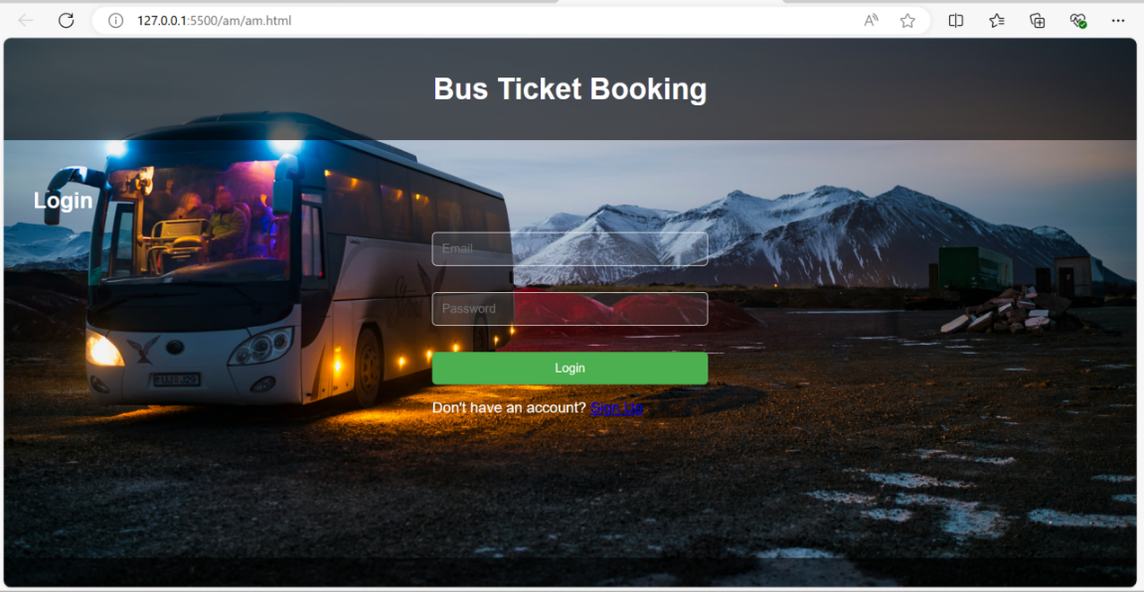

**Project Plan (Date-wise and Task-wise):**

|  |  |  |  |  |  |  |  |  |  |
| --- | --- | --- | --- | --- | --- | --- | --- | --- | --- |
| DURATION / TASK | 21.06.2024 | 22.06.2024 | 23.06.2024 | 24.06.2024 | 25.06.2024 | 26.06.2024 | 27.06.2024 | 28.06.2024 | 29.06.2024 |
| LITERATURE SURVEY |  |  |  |  |  |  |  |  |  |
| REQURIMENT ANALYSIS |  |  |  |  |  |  |  |  |  |
| DESIGN AND PROTOTYING |  |  |  |  |  |  |  |  |  |
| FILE SYSTEM MANAGEMENT |  |  |  |  |  |  |  |  |  |
| METADATA MANAGEMENT |  |  |  |  |  |  |  |  |  |
| INTEGRATED TESTING |  |  |  |  |  |  |  |  |  |
| EVALUATION |  |  |  |  |  |  |  |  |  |
| DEMO |  |  |  |  |  |  |  |  |  |
| PRESENTATION |  |  |  |  |  |  |  |  |  |